**Cloud Computing**

**Job Roles:**

1. Cloud Developers

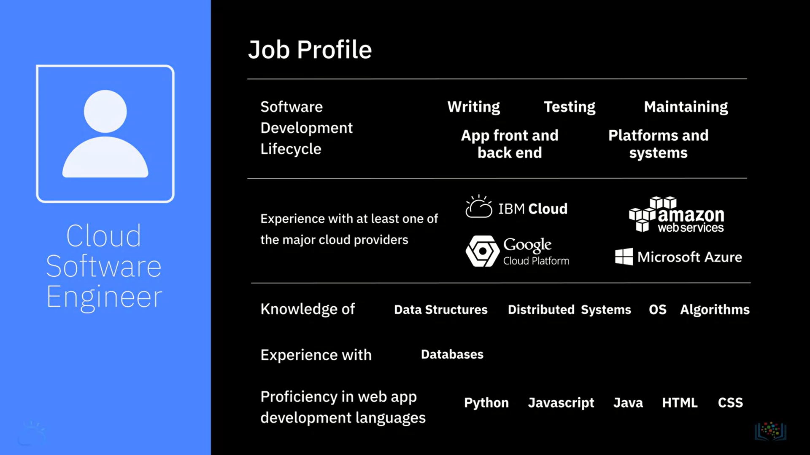

1. Cloud Integration Specialists

1. Cloud Data Engineers

1. Cloud Security Engineers

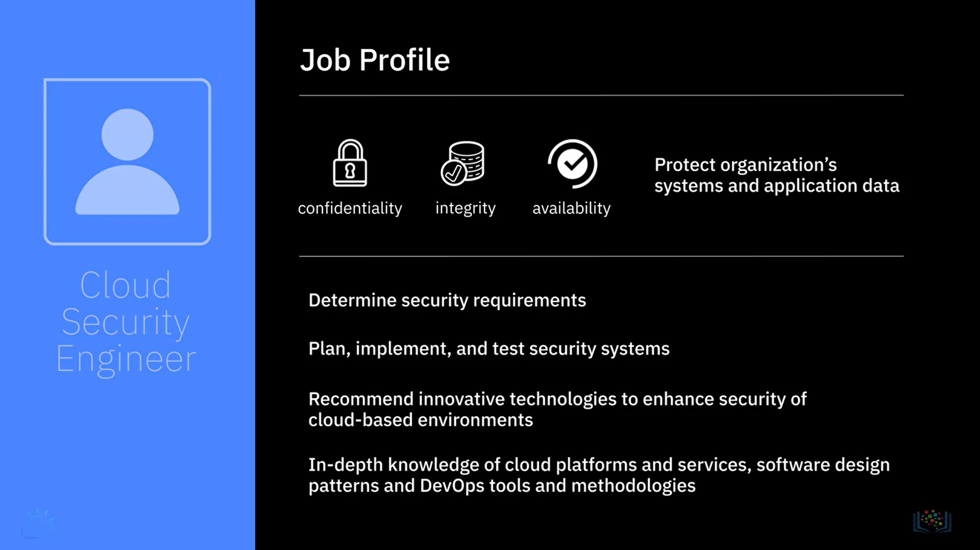

1. Cloud DevOps Engineers

1. Cloud Solutions Architects

